THE UGANDA INTERGOVERNMENTAL FISCAL TRANSFERS (UGIFT)

REPORT ON THE FINDINGS OF HEALTH CENTERS AND SCHOOLS IN MARACHA DISTRICTS
WEST NILE SUB-REGION

Date: 8TH / 09/ 2026

MARACHA DISTRICT – WESTNILE SUB -REGIO.
CAO:
- Mr. Erisu Peter Emwos though was not in office but he made sure we were warmly welcomed as team by his deputy and He introduced us to the DEO, DHO and Accounting office.
- They helped the team to inform the focal person on the facilities.
- The district did not have the specific UGIFT Asset register for the UGIFT asset that were provided to the specific facilities in our Scope.

LIKO HEALTH CENTER III, DRAMBU SUB-COUNTY – MARACHA DISTRICT
The in charge of the facility was present and he warmly welcomed us as a team. He said that to a larger extent the facility has benefited from the UGIFT Programme in many ways.

FINDINGS
- 1 maternity ward building and OPD
- 1 Toilet and bath room with 4 units
- 1 power house with solar
- 7 water tanks and 4 water points
- All the required medical assets as listed in the attached facility register below and some of the photos.
- 1 Residential house for medical staff with 2 stances
- 1 kitchen and I toilet with 2 units

CHALLENGES
- Few medical personnel
- Few staff quarters
- Lack of electricity
- Lack of fence for the facility

RECOMMENDATIONS
- Employ more medical personnel’s
- Need for fence to avoid insecurity
- Build more staff quarters

IMAGES FROM SOURCE
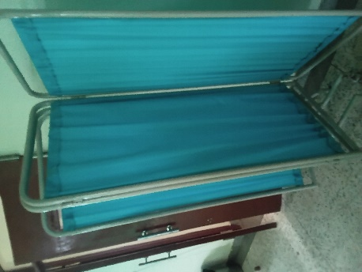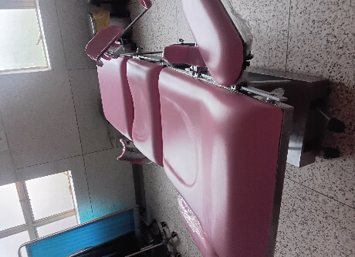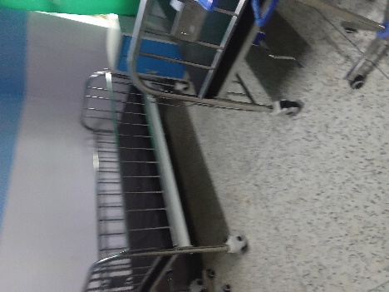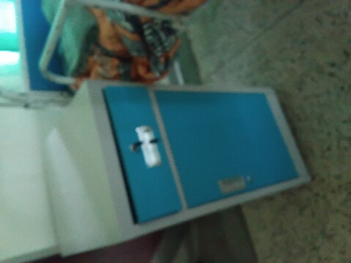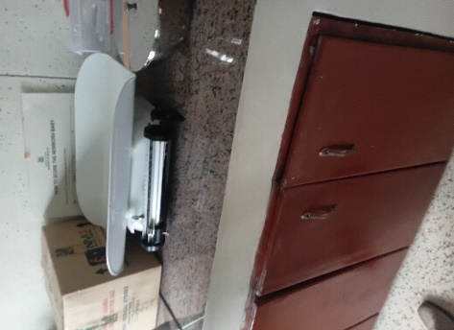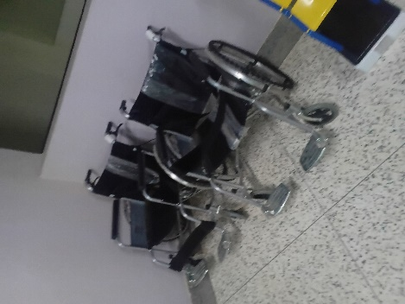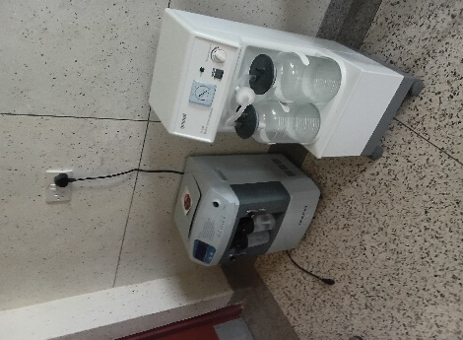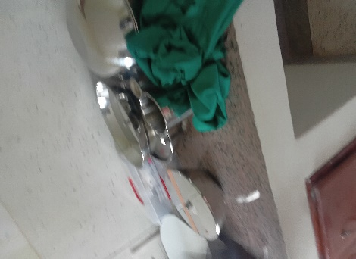
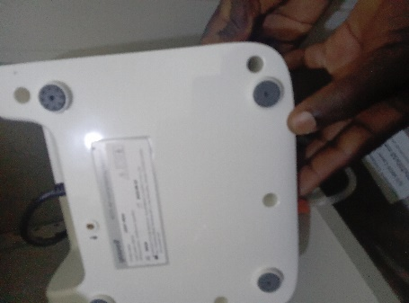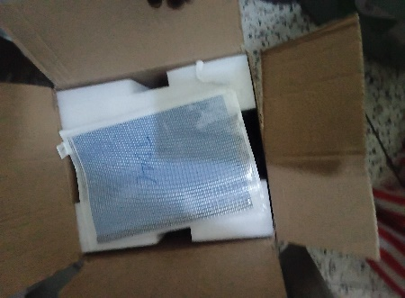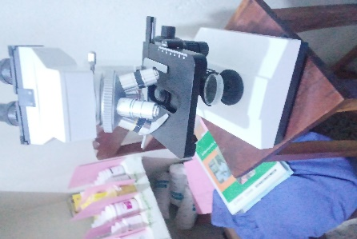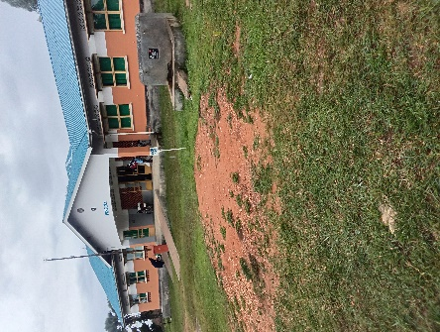
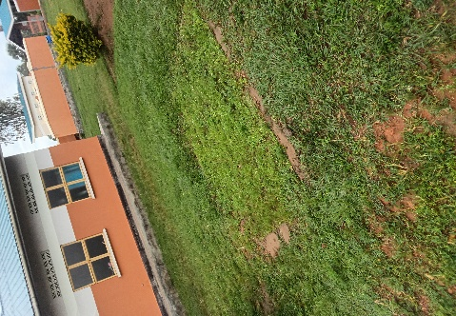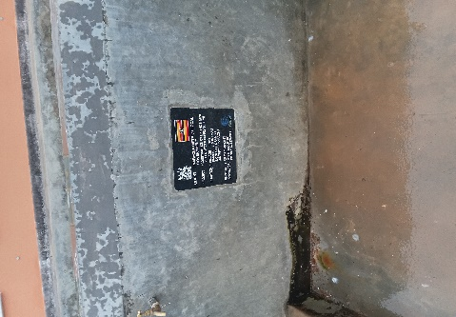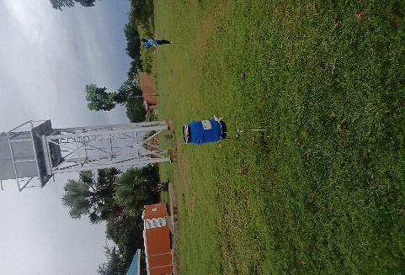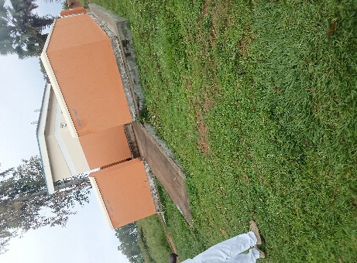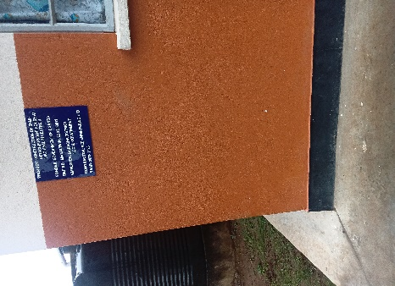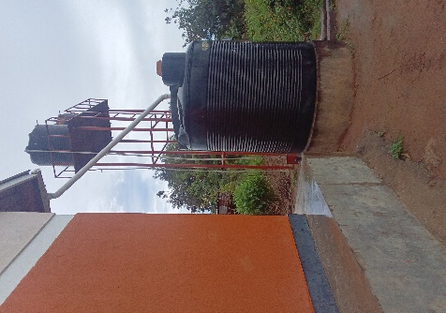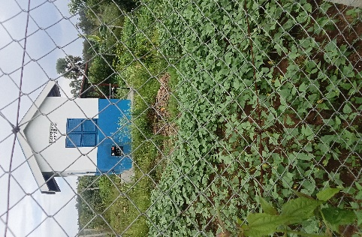

KOLOLO PUBLIC SEED SECONDARY SCHOOL, TARA SUB COUNTY IN MARACHA DISTRICT
Information from the focal person in charge of the facility. He warmly welcomed the team and took the team through the asset and facilities, the school so far benefited from UGIFT Programme.
NB: the facility has no asset register for UGIFT assets. The work at the facility was substantially done.

FINDINGS
- 3 Blocks each with 2 class rooms
- 1 Science laboratory block with two labs i.e. Biology and Chemistry
- 1 ICT block with two labs i.e. Computer room and Library room
- 6 Staff house units with 6 staff Kitchen units
- 2 Toilets at staff quarters each with 2 stanzas
- 1 staff school toilet with 2 stanzas
- 2 student toilets for both girls and boys each with 5 stanzas
- 1 big gas Cylinder
- 1 school pitch
- Not fenced

FURNITURE
- 120 Desks, 20 per class
- 20 Tables
- 24 book shelves
- Stools for laboratories
- 12 office chairs
- 303 Wooden and Metallic chairs
- 6 War drops

ICT DEPARTMENT
- 28 Desktop computers
- 28 UPS
- 1 Set desktop projectors
- 2 pcs switch(24port)
- 1 server high end desktop
- 1 CCTV Camera
- 1 Server UPS
- 10 Power serge projector
- 2 wireless routers
- 1 air conditioner
- 2 patch panel 48 port
- 1 internet connect

CHALLENGES
- Have no stools in the labs
- The facility is not fenced
- Have no reliable power source/Supply
- Pathways and compound not well-grounded
- Furniture is incomplete

IMAGES FROM SCHOOL

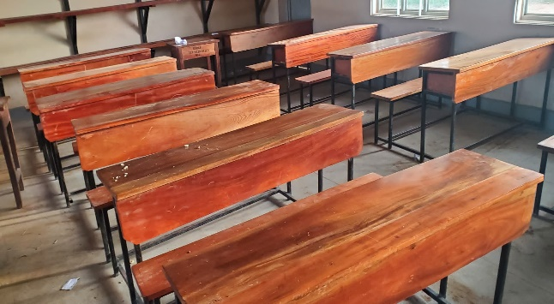
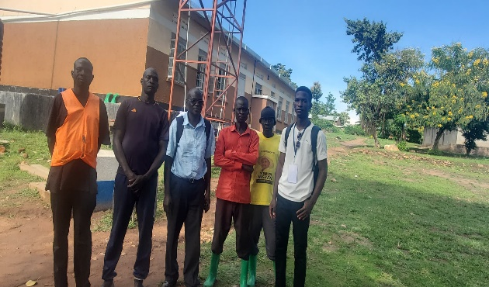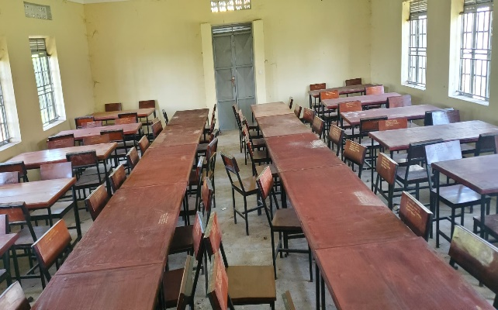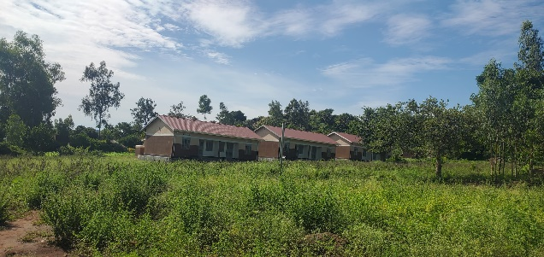
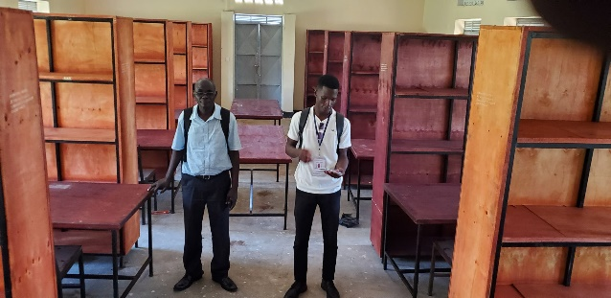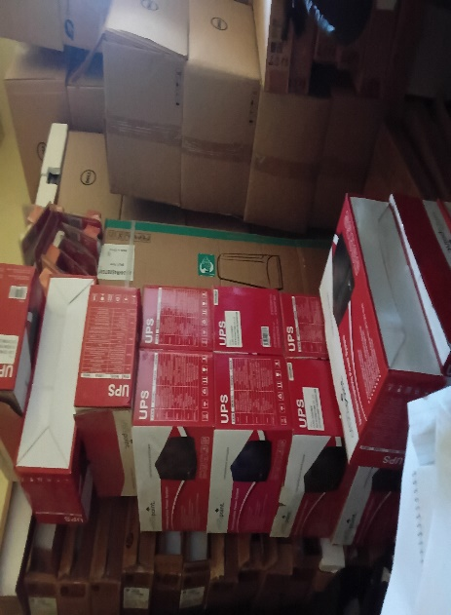

ALL SAINTS SEED SECONDARY SCHOOL, OLUVU SUBCOUNTY IN AGAGO DISTRICT
information from the focal person in charge of the school. The Head Teacher of the school welcomed the team happily and managed to take us through the buildings of the facility.

FINDINGS: SCHOOL FURNITURE
The school have not yet received the school furniture because it is still under construction

SCHOOL BUILDINGS
- 3 Blocks of classes, each block has two classes equivalent to 6 classes
- 1 Block of science laboratory with two science rooms with stores.
- 1 Block with ICT laboratory and library.
- 1 Block with school offices and staff room
- 1 Multi -Purpose hall equivalent to 3 classes
- 3 Staff housing Block, each block has 2 house units
- 3 Staff kitchen blocks and each block has 2 kitchen units
- 3 blocks of staff quarters toilets and toilet has two stanzas
- 1 school football pitch not yet constructed
- 2 school toilets that is 2 for the student both girls and boys each with 5 stanzas ➢ 1 toilet is for school staff with 2 stanzas

ICT DEPARTMENT

- 21 Desktop computers
- 1 Set desktop projectors
- 2 pcs switch(24port)
- 1 server high end desktop
- 1 CCTV Camera
- 1 Server UPS
- 10 Power serge projector
- 2 wireless routers
- 1 air conditioner
- 2 patch panel 48 port

CHALLENGES
- Delay in Construction
- Lack of school fence
- Unreliable water supply
- Unreliable power supply

RECOMMENDATIONS
- Review the constructors of the construction
- Provide reliable water source
- Provide reliable power supply
IMAGES FROM THE SCHOOL
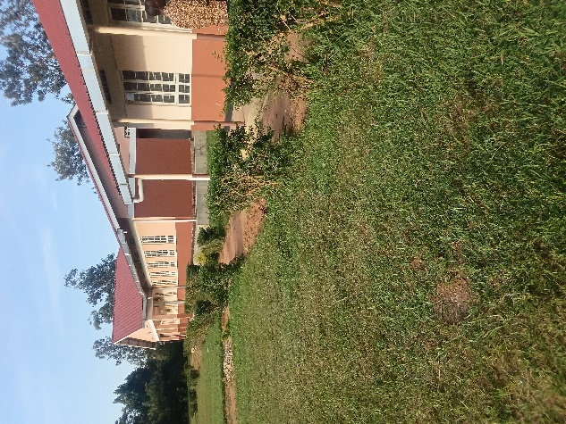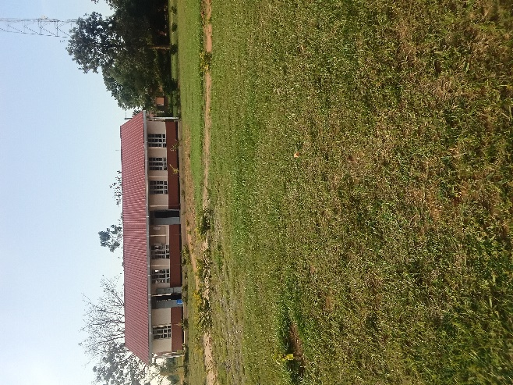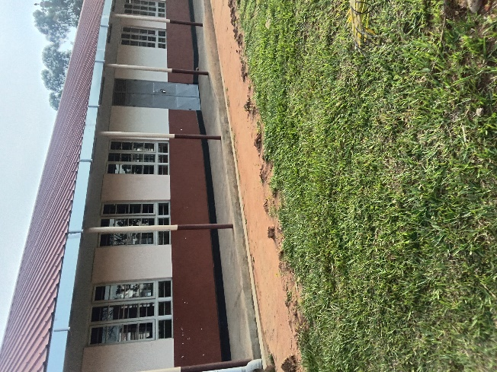
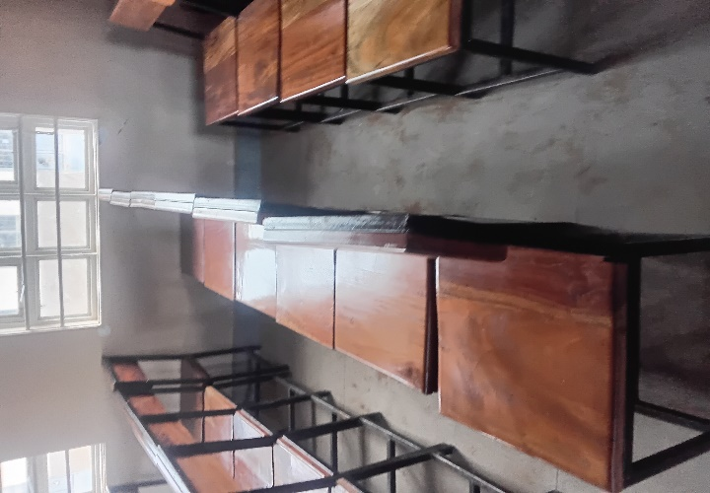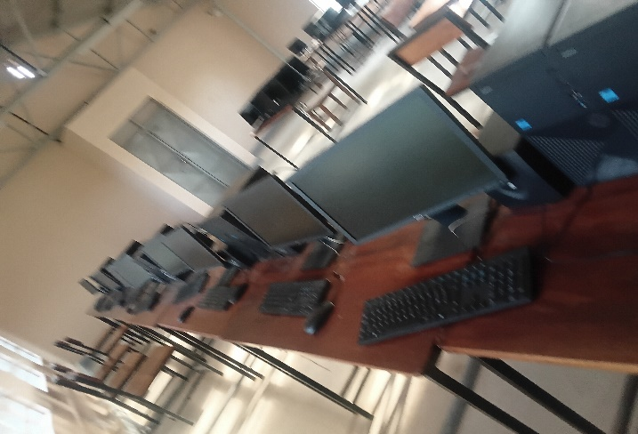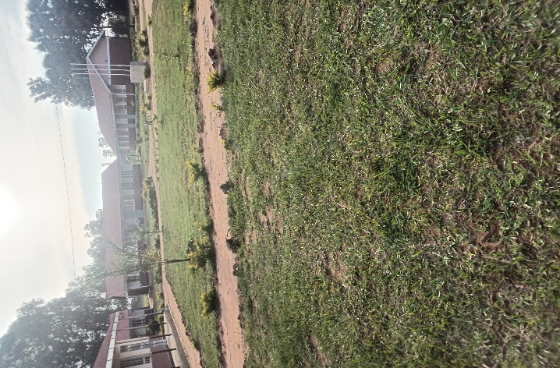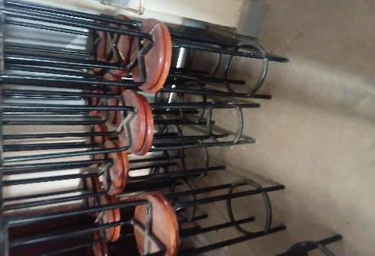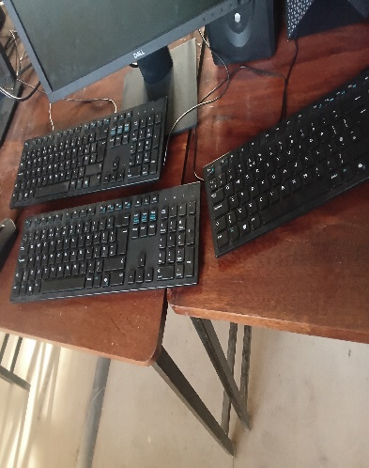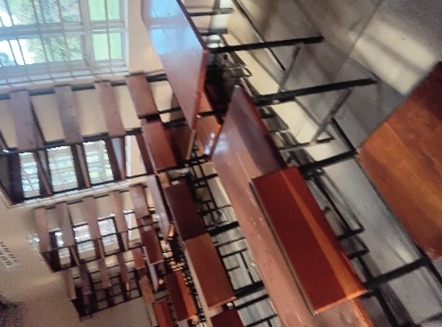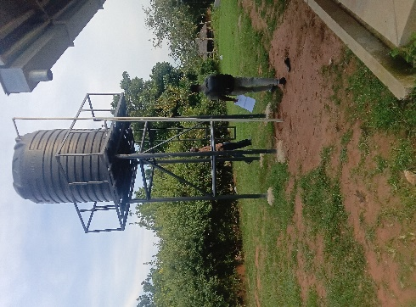

EKALIGO HEALTH CENTRE III IN KIJOMORO SUB COUNTY – MARACHA DISTRICT
Information from the person in charge of the facility
The in charge of the facility warmly welcomed the team and proceeded to take the team through what so far the facility has benefited from the UGIFT Programme

FINDINGS

BUILDINGS (NON-RESIDENTIAL)
- 1 Maternity and general ward building
- Received only 20 paediatric beds with mattresses
- 1 Toilet with 4 stanzas
- 3 water tanks 1 for staff and 2 for the health facility.
- Fence with a gate
(RESIDENTIAL)
- 1staff block with two staff houses
- 1 kitchen and bathroom then toilet with 2 units
- 1 water tank connected

NB: All are incomplete and are substandard done. This is evidenced with the attached photos

CHALLENGES
- Under Staffing
- Power Problem
- Delay in implementations
- Most of the beds are not assembled
- Wheel chairs are not working due to flat tires

RECOMMENDATIONS
- Employ more medical workers
- Provide reliable power supply
- Need to assembly the beds
- Need to work on the wheel chairs

IMAGES FROM THE SOURCE
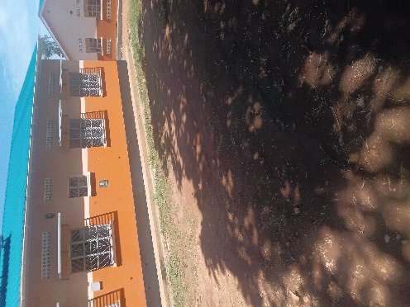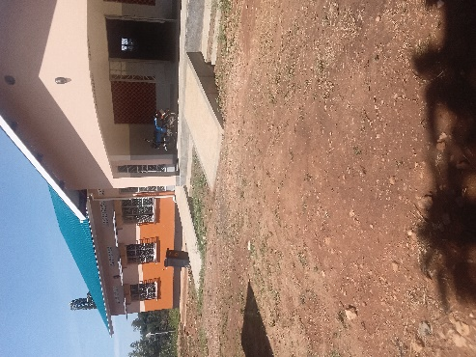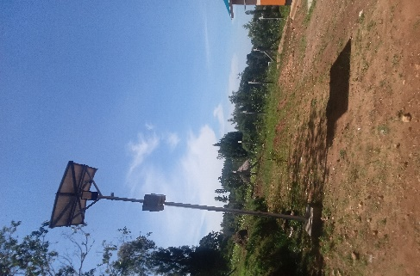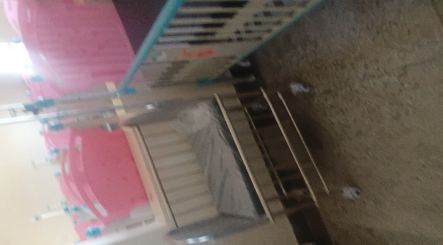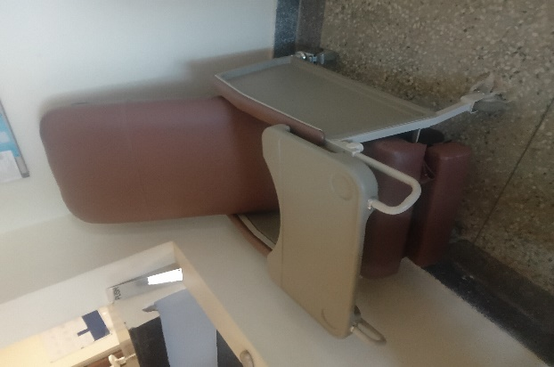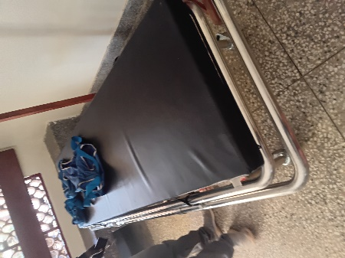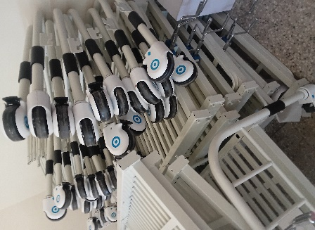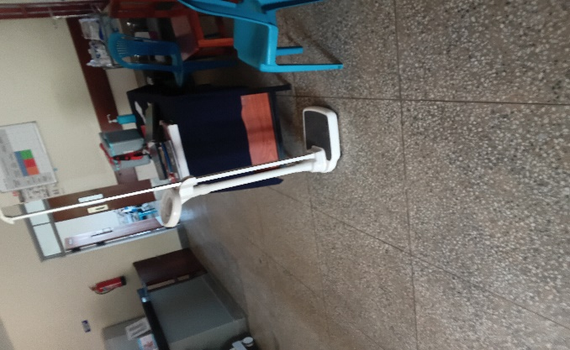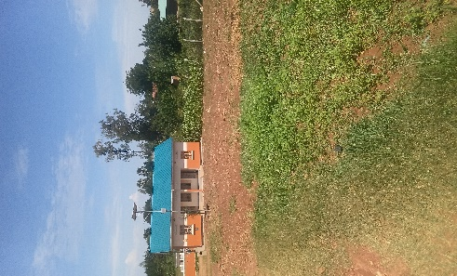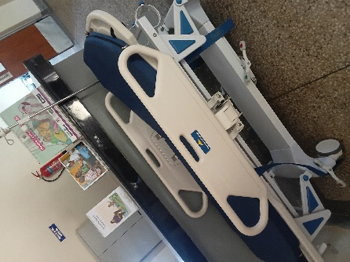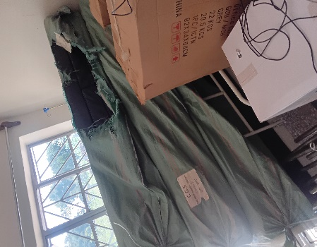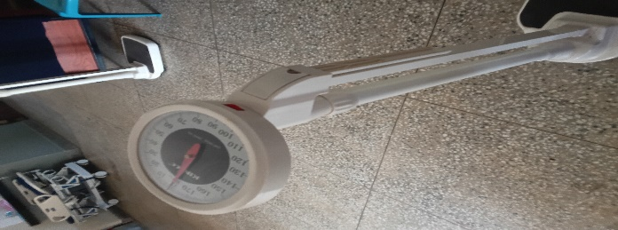
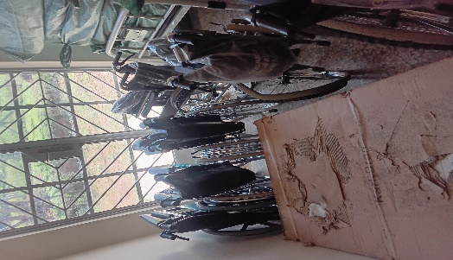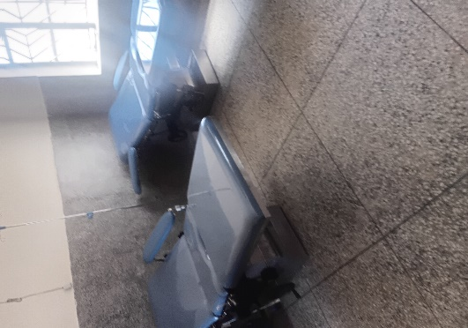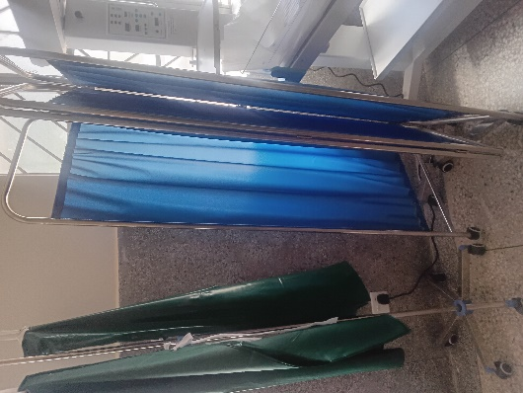

CURUBE HEALTH CENTER III IN AWIZIRU SUB COUNTY MARACHA DISTRICT.
The information from the person in in charge of the facility.
The in charge of the facility warmly welcomed the team. He took us through out the whole process and explained every single equipment under Ugift

FINDINGS
- 1 kangaroo mother care
- 10 beds with mattresses
- 1 block containing general ward and maternity
- 1 toilet and bathroom with 4 units
- 1 residential block for staff with 2 stances
- 1 toilet for staff with 2 units and bathroom
- 2 big water tanks for both health facility and the staff.

CHALLENGES
- Lack of power supply
- Limited staff blocks
- No reliable water sources
- Few water tanks
- All the wheel chairs are not working due to flat tyres

RECOMMENDATIONS
- Need to repair the wheel chairs.
- Provide Power Supply
- Provide reliable water sources
- More water tanks are needed
NB: The facility has a big for non residential which contains a l of equipment’s and some which are shown on the images

IMAGES FROM THE FACILITY.
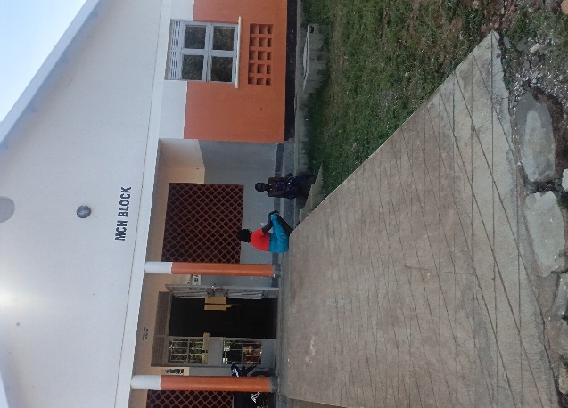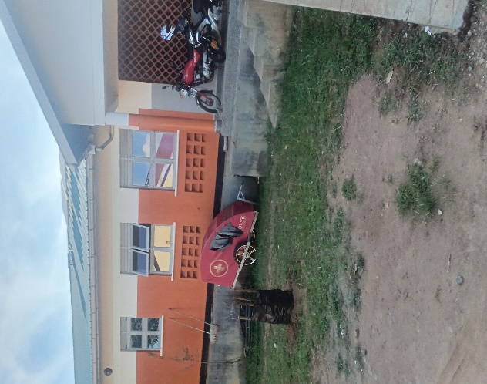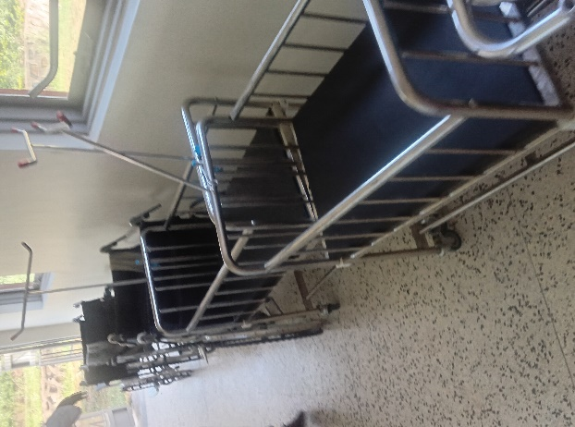
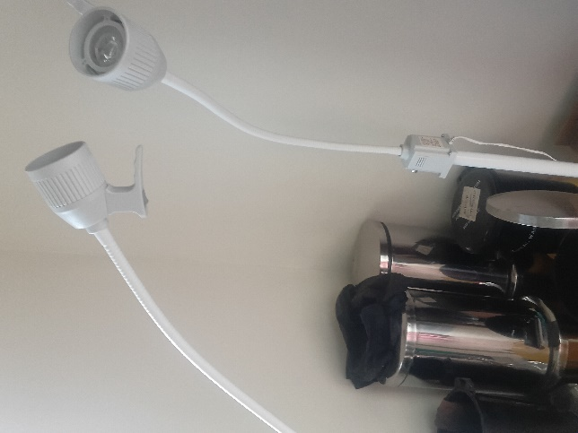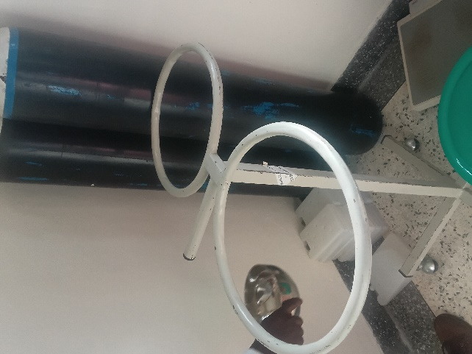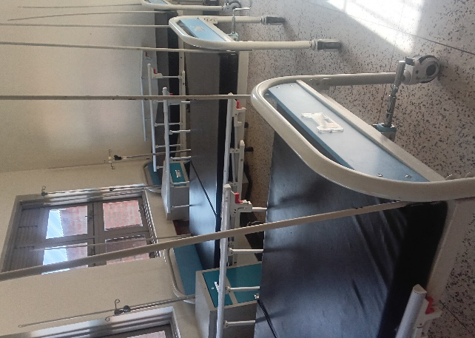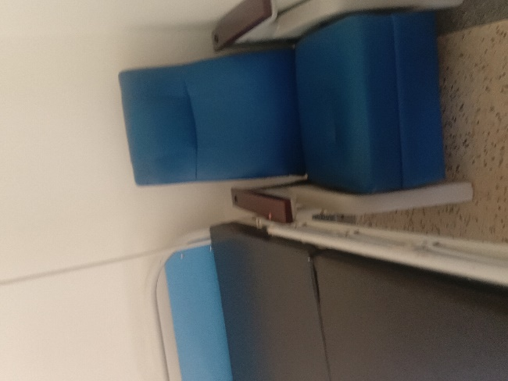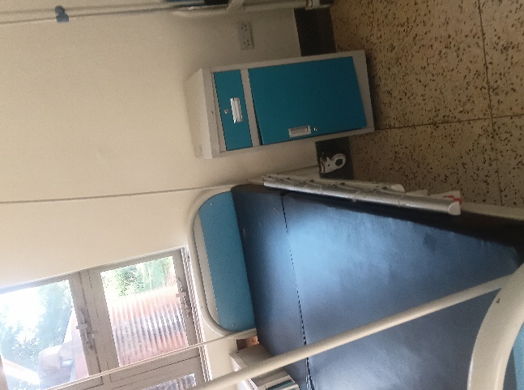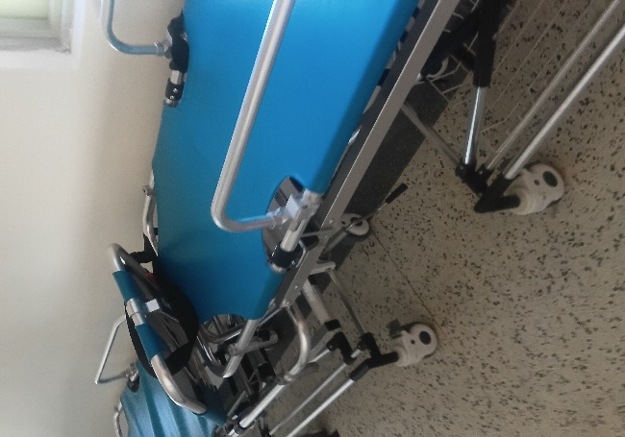

AJIKORO HEALTH CENTER III IN PARANGA SUB COUNTY MARACHA DISTRICT.
Information from the responsible people in charge. The in charge of the facility warmly welcomed the team. To a larger extent the Ugift programme has many benefits to the facility.
FINDINGS
1 Big block containing general ward and maternity ward.
I Toilet containing bathrooms with 4
4 Patient screens
1 Examination couch
6 Bed side lockers
Hand over records from HCII TO HCIII
Some of asset records
NB: all other information are recorded in the tool and few on the pictures.
Challenges
- Lack of fence
- Lack of reliable water source
- Few staffs or medical personnel
- Few equipment’s
- Lack of electricity

Recommendations
- Need for more staffs for the health centre
- Need for electricity
- Need for reliable water source

PHOTHOS OF THE EQUIPMENTS OF AJIKORO HEALTH CENTER II
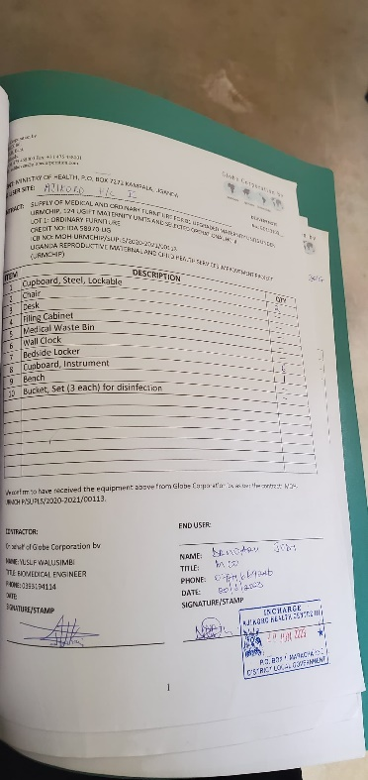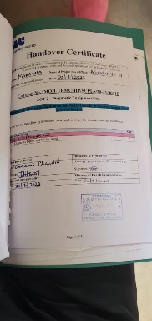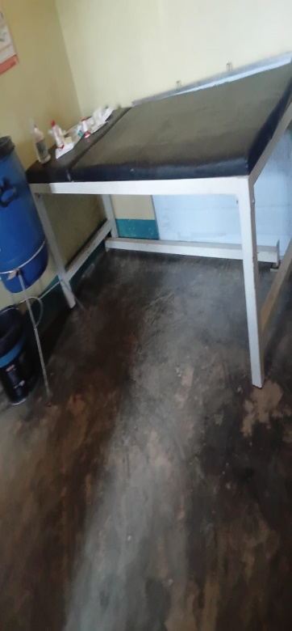
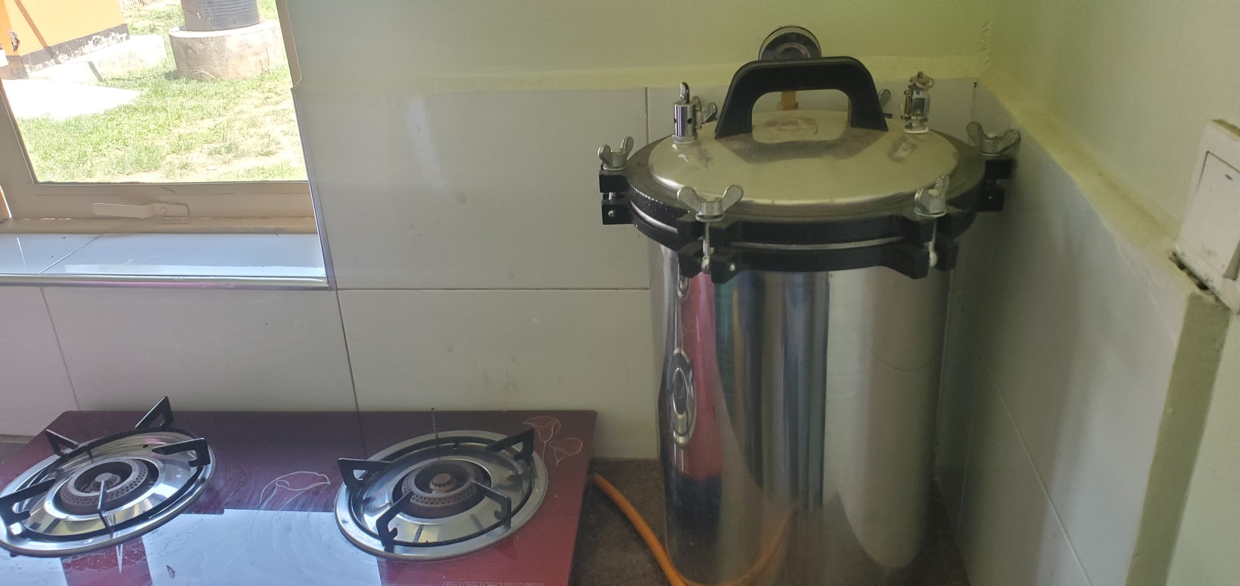
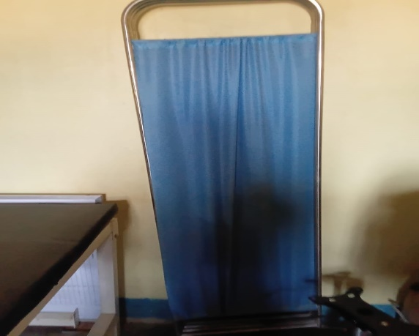

UDUPIRI HEALTH CENTER III, TARA -SUBCOUNTY – MARACHADISTRICT
Narratives from the focal person in charge of the facility. The in charge was on leave and there were no asset records for UGIFT assets. The person in charge took us through out the whole process .

FINDINGS
- 1 maternity ward building and general word
- 1 OPD building which is still incomplete inside and
- 1 Toilet with 4 units
- 1 Filing cabinet
- 2 examination lights
- Drip stands
- Autoclave
- Admission beds
- All the required medical assets as listed in the attached facility register below and some of the photos.
- 2 Residential houses for medical staff with 4 units

CHALLENGES
- Few medical personnel
- Few staff quarters
- Lack of electricity bad roads coming to the health center
- Un reliable water source near the facility

RECOMMENDATIONS
- Employ more medical personnel’s
- Provide reliable water source
- Need for electricity
- Build more staff quarters

IMAGES FROM SOURCE
